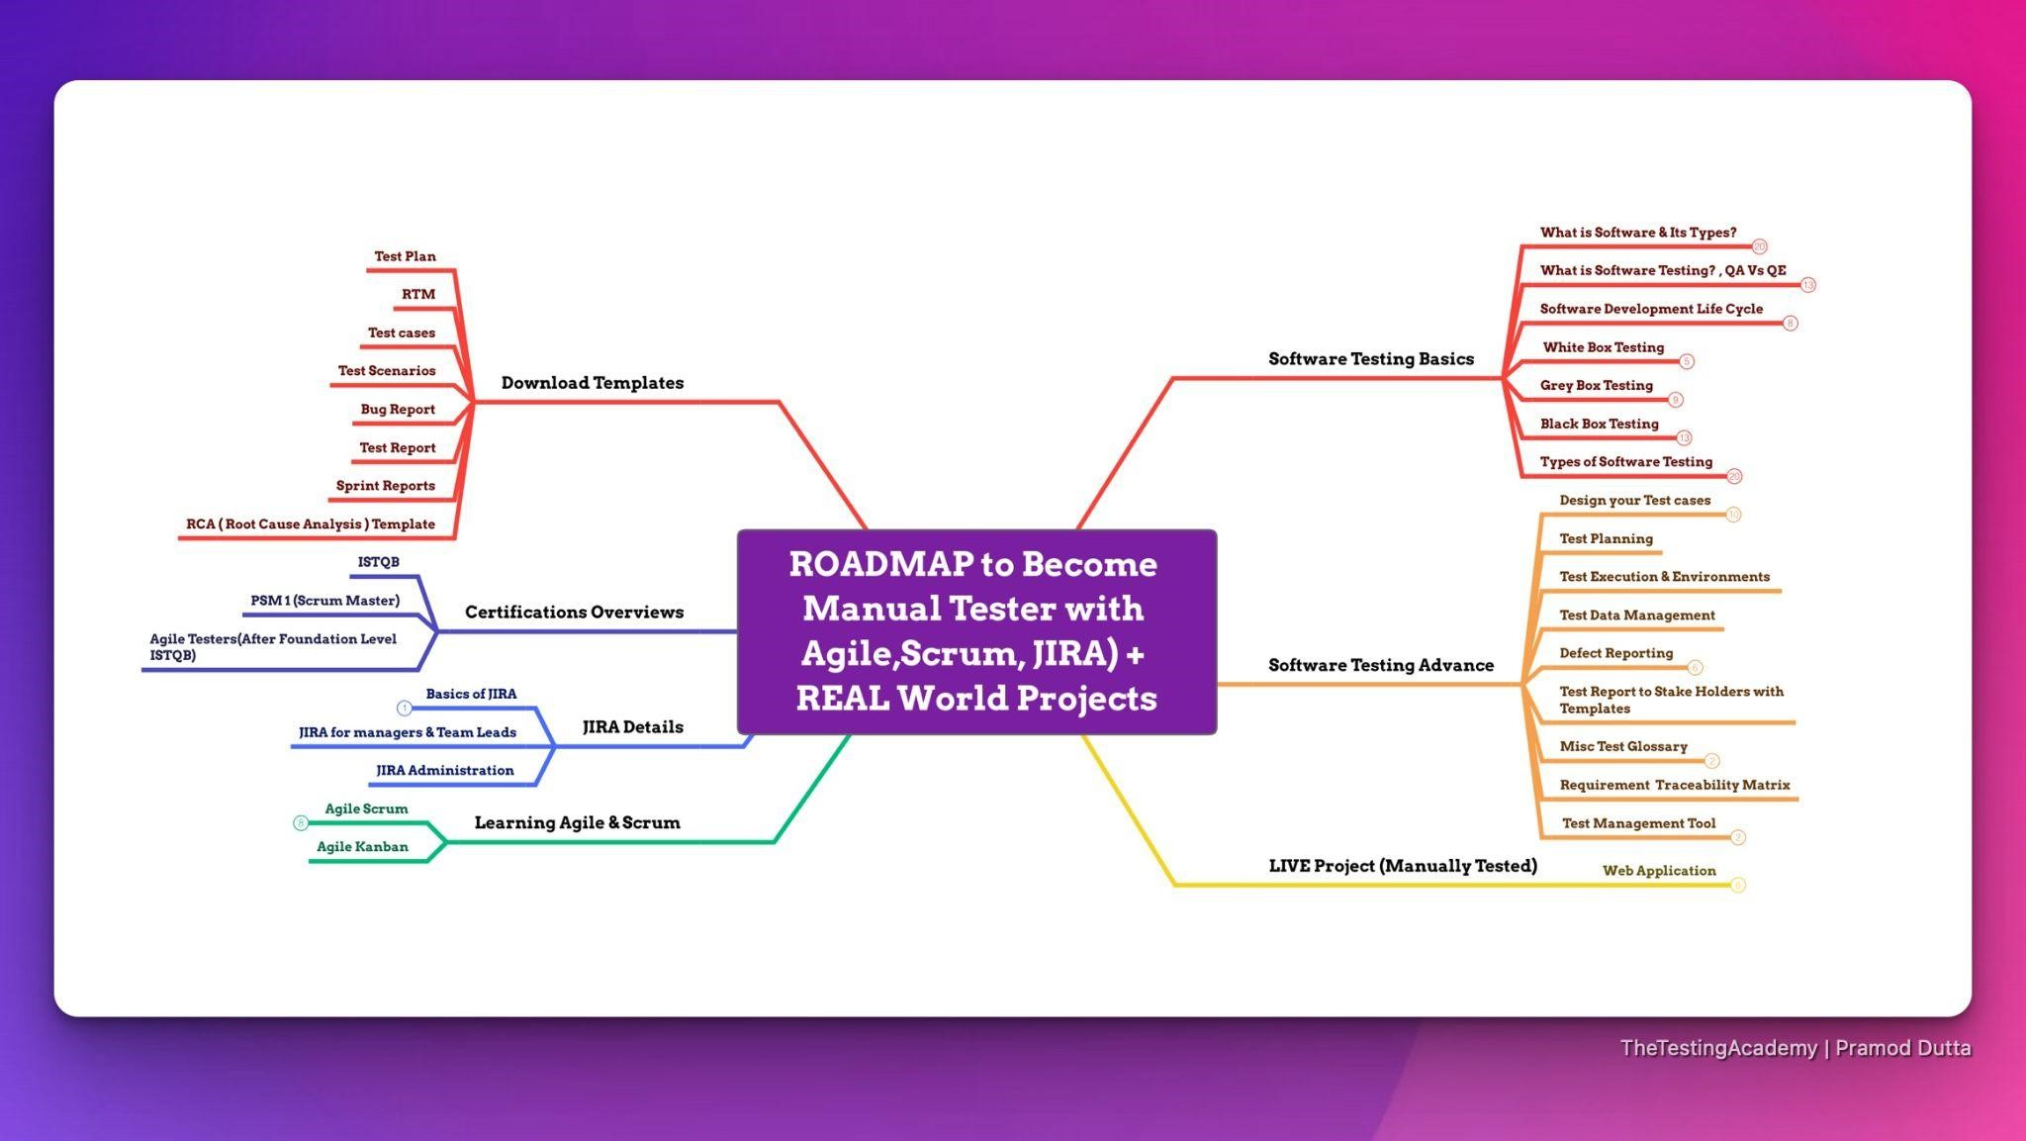

Agenda

* **Introduction to Software Testing?**
* **Details on SDLC and Different Models.**
* **STLC Life Cycle & 7 Principles of Software Testing.**
* **RTM & Different Types of Software Testing.**
* **Test Design Techniques**
* **Bugs, Severity vs Priority**

## Rules

**Focus on One**

**Thing.**

**5**

**% : 95% Rule**

**70**

**% is Perfect**

**100**

**% is Failure**

**New Action**

**Commitment!**

**Block at least**

**3-4 hour Per Week.**

Laptop - 8 GB Ram,

512 GB HDD (SDD)

Mobile - Yes

Excel, PDF

Resume Building, LinkedIn,

ChatGPT(How to get Job)

**What is Software?**

**Software is basically a set of instructions or commands that tells a computer what to do**

**What is Software?**

# Types of Softwares

* **System software**

**Ex: Device drivers, Operating Systems, Servers, Utilities, etc.**

* **Programming software**

**Ex: compilers, debuggers, interpreters, etc.**

* **Application software**

**Ex: Web Applications, Mobile Apps, Desktop Applications etc**

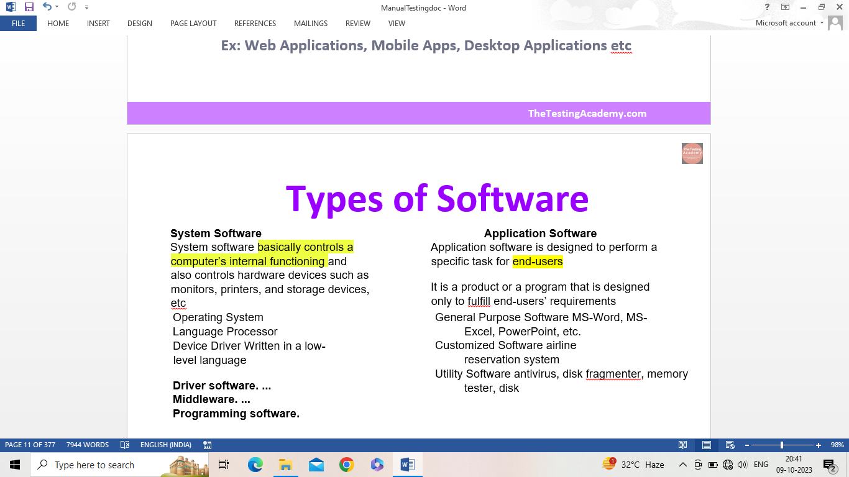

Software testing is the process of evaluating and verifying that a software product or application does what it is supposed to do.

Expect Result ( Requirement)

= Actual Result ( By doing it / QA)

Software Testing is a part of software development process.

Main Objective of testing is to release quality product to the client.

Activity to detect and identify the defects in the

Software. (Not Fix)

What are software testing objectives and purpose?

What are software testing objectives and purpose?

To prevent defects.

# Finding defects

Gaining confidence in and providing information about the level of quality

end result meets the business and user requirements.

ensure that it satisfies the BRS that is Business Requirement

gain the confidence of the customers by providing them a quality product.

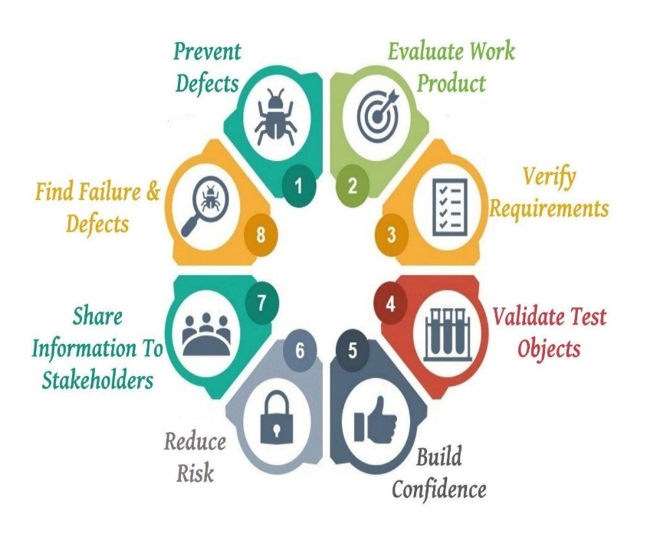

Quality

**Quality is defined as justification of all the requirements of a customers in product.**

**Quality software is Means**

* Bug-free
* Delivered on time.
* Within budget.
* Meets requirements and/or expectations.
* 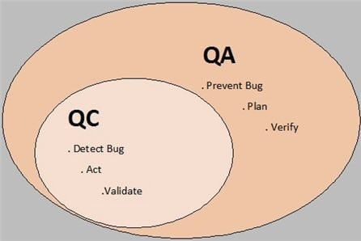Maintainable

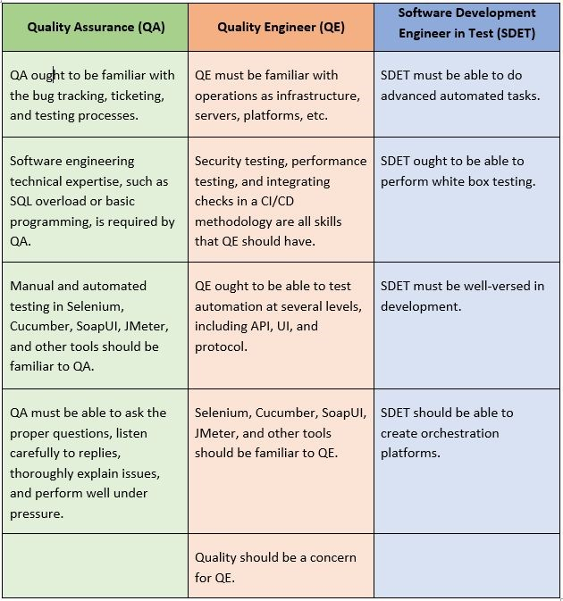

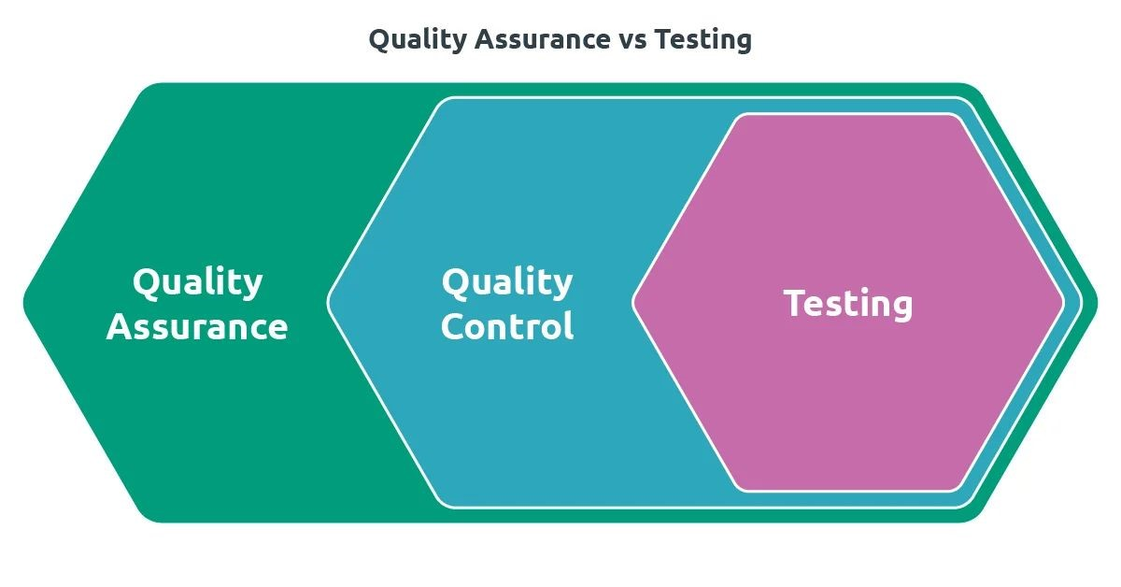

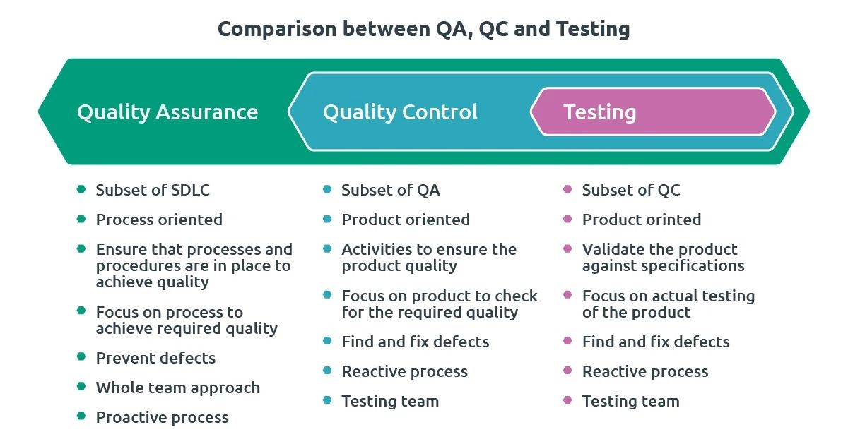

**Software Testing**

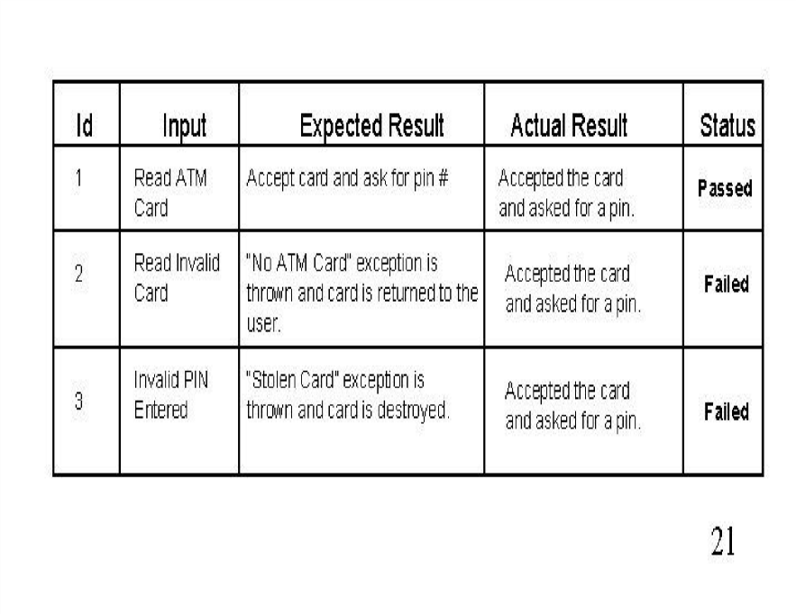To check whether the **Actual** software product matches **Expected** requirements and to ensure that software product is Defect free.

**Why Software Testing is Important?**

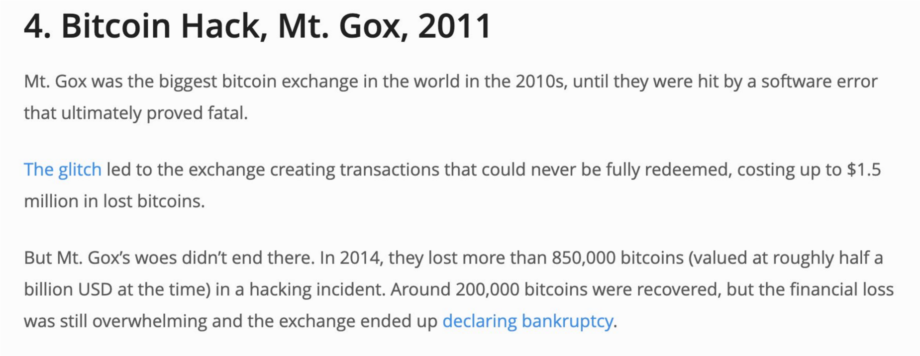

https://raygun.com/blog/costly-software-errors-history/

**Why Software Testing is Important?**

Vulnerability in Windows 10. This bug enables users to escape from security sandboxes through a flaw in the win32k system.

China Airlines Airbus A300 crashed due to a software bug on April 26, 1994, killing 264 innocents live

https://raygun.com/blog/costly-software-errors-history/

### Benefits of Software Testing

* Cost-Effective
* Product quality
* **Customer Satisfaction**

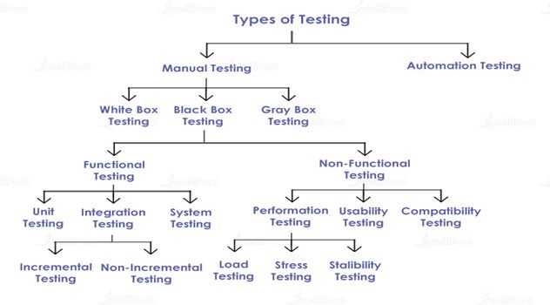

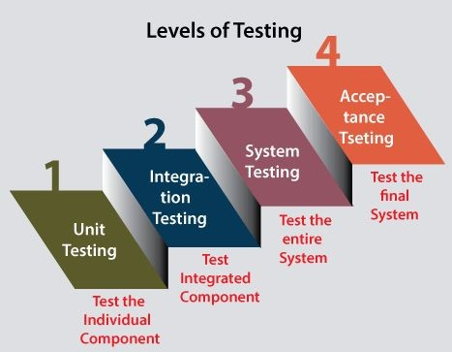

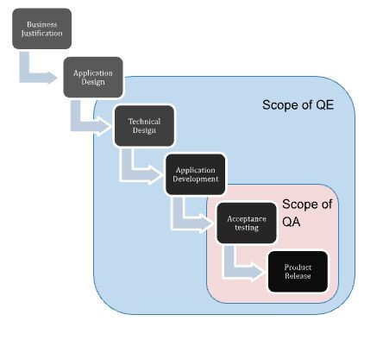

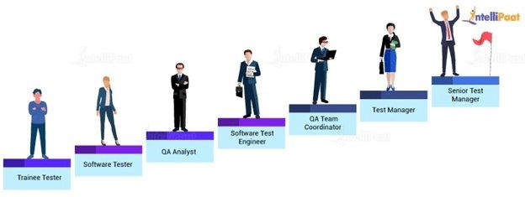

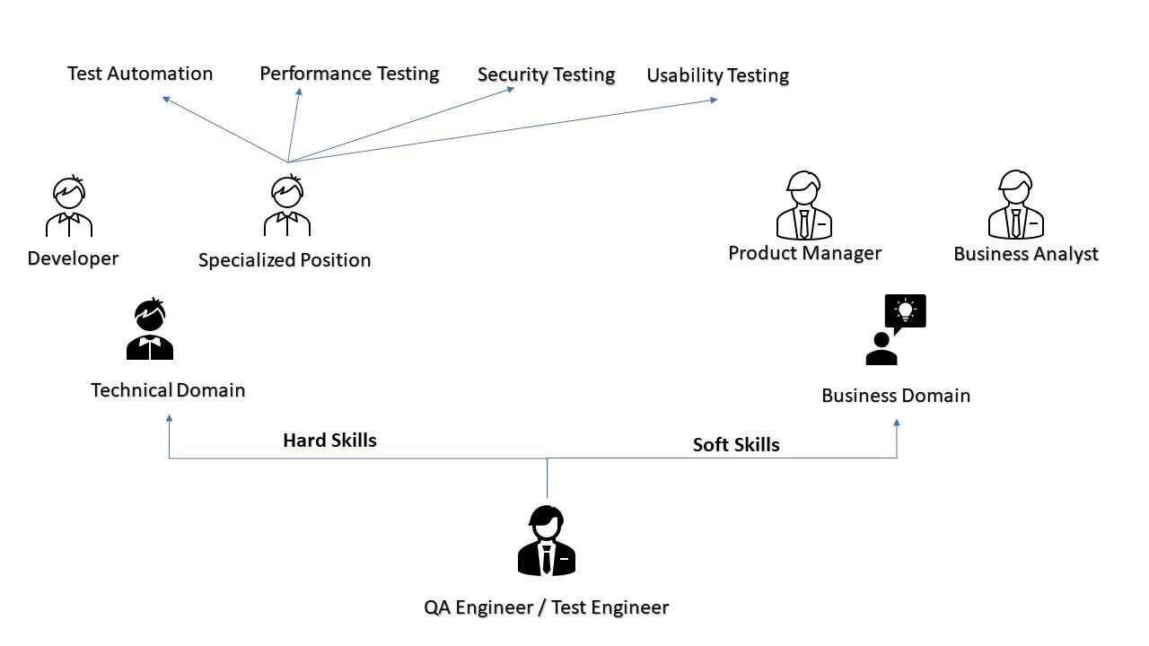

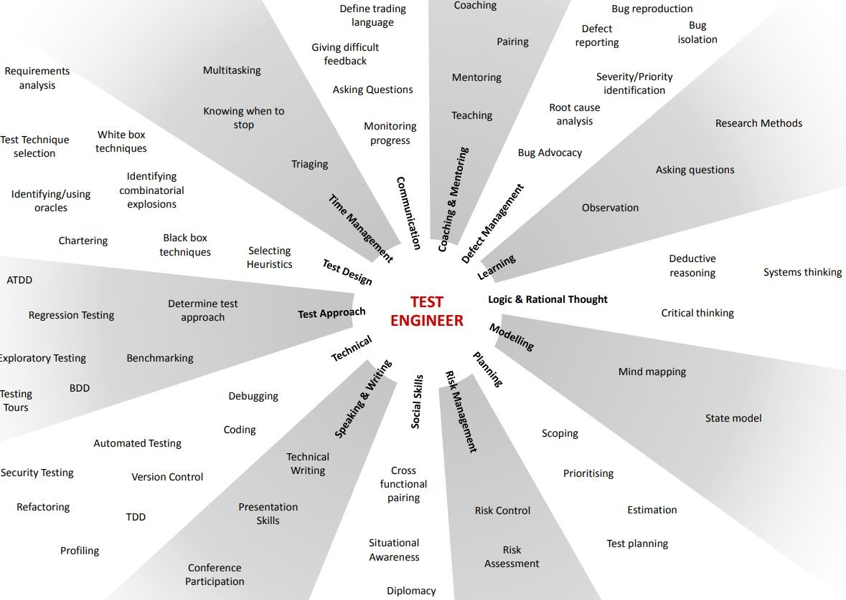

### Types of Software Testing Functional Testing Non-Functional Testing

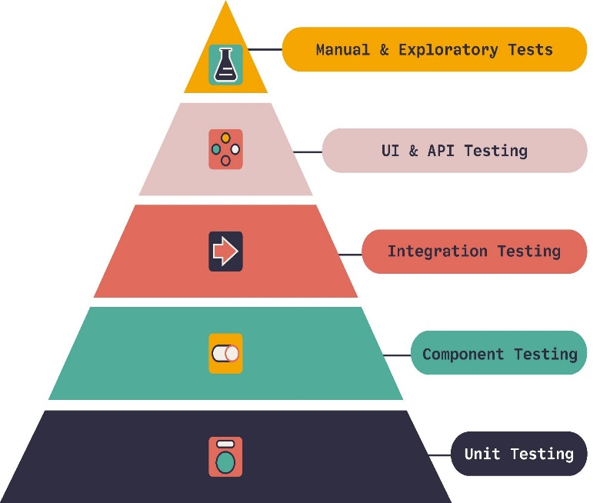**Testing Pyramid**

### 

### Unit Testing

**Type of software testing** where **individual units** or components of a software are tested

Unit tests help to fix bugs early in the development cycle and save costs.

**A developer writes a section of code in the application just to test the function. They would later comment out and finally remove the test code when the application is deployed.**

A coder generally uses a **UnitTest Framework** to develop automated test cases

**Code coverage techniques used in Unit Testing**

* 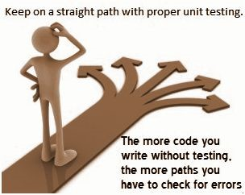**Statement Coverage**
* Decision Coverage
* Branch Coverage
* Condition Coverage
* Finite State Machine Coverage

**Unit Testing**

Demo of Web App unit

isSumPositive function

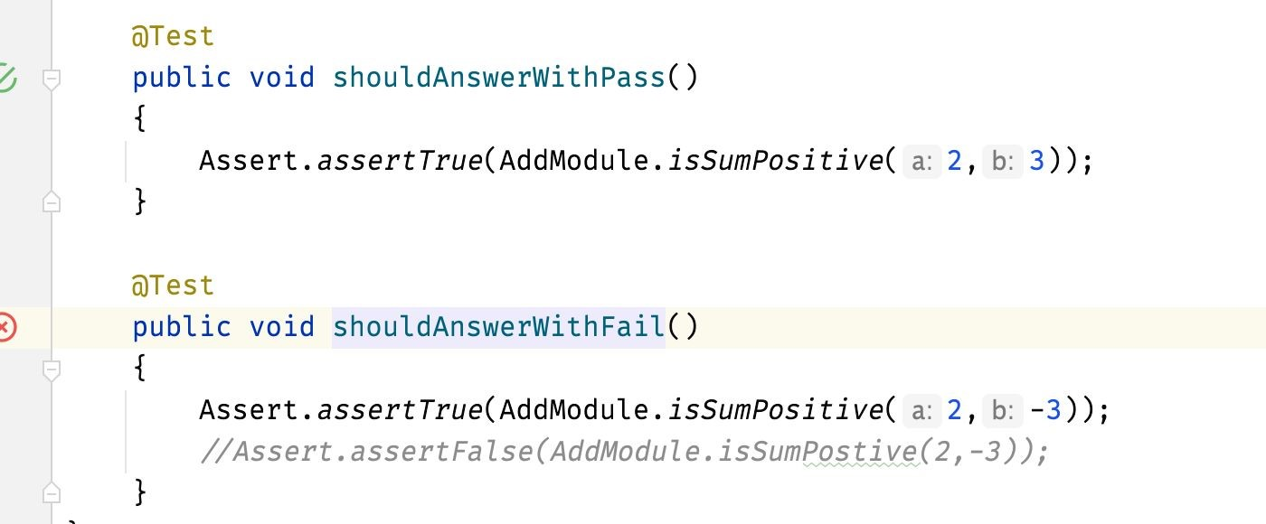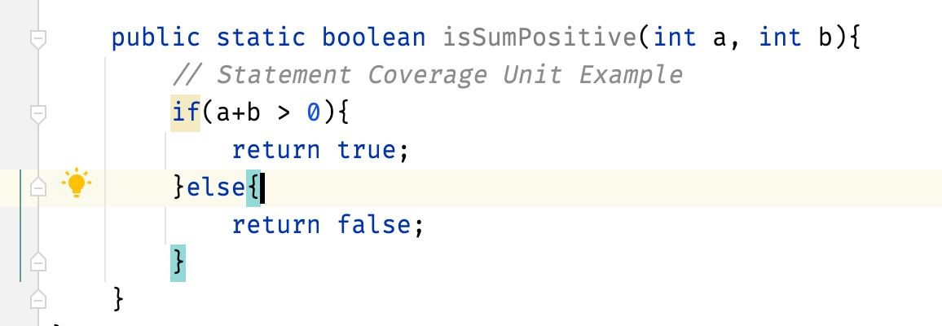

**Statement Coverage!**

Statement coverage is a type of software testing that aims **to ensure that every statement in a program has been executed at least once during testing.** This means that every line of code is tested, but not necessarily every 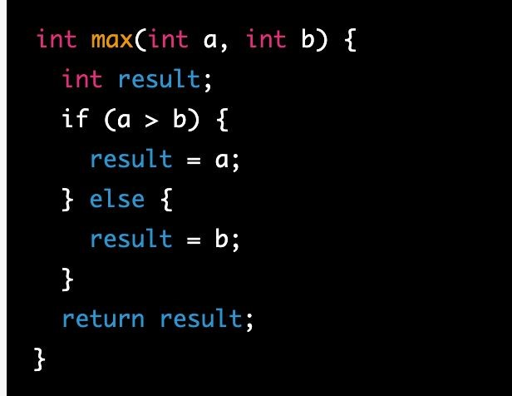possible path through the code.To achieve **100% statement coverage for this code**,

write a test case where a is greater than b, and another test case where b is greater than or equal to a.

This would ensure that both branches of the if statement are executed at least once, as well as the assignment and return statements.

#### Decision Coverage

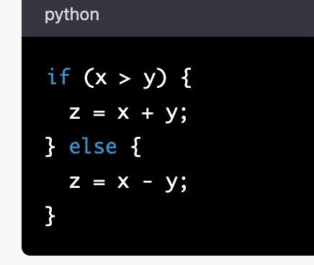Ensuring that all possible outcomes of a decision or boolean expression have been evaluated

This means that each possible true or false outcome must be tested at least once.

To achieve 100% decision coverage,

we would need to test both the true and false outcomes of the boolean expression x > y. So,

we might write two test cases: one where x is greater than y, and one where x is not greater than y

#### Branch Coverage

Each possible path through a piece of code must be executed at least once. we would need to test both the true and false outcomes of the boolean expression x > y, as well as both branches of the if statement.

#### Condition Coverage

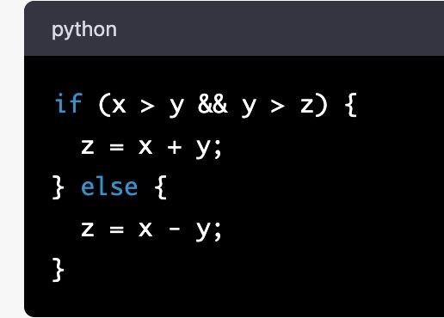Condition coverage is similar to decision coverage, but it focuses specifically on ensuring that each possible combination of boolean sub-expressions within a decision have been evaluated

we would need to test all possible combinations of the sub-expressions x > y and y > z.

This means we would need to test the true-true, true-false, false-true, and false-false combinations.

**Finite State Machine Coverage**

Finite state machine coverage is a testing technique that focuses on ensuring that all possible states and transitions within a finite state machine have been tested.

consider a vending machine that dispenses snacks:

State 1: Idle

-> Money inserted: transition to state 2

State 2: Selecting product

-> Product selected: transition to state 3

-> Money refunded: transition to state 1

State 3: Dispensing product

-> Product dispensed: transition to state 1

To achieve 100% finite state machine coverage, we would need to test every possible combination of starting state and transitions within the machine.

### Integration Testing

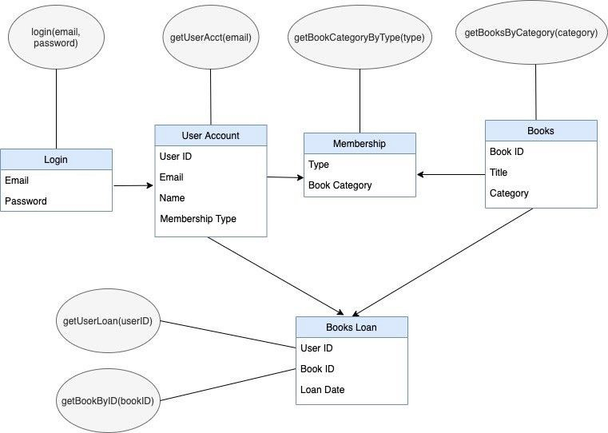Type of software testing where 2 or more unit combined.

Software modules are integrated logically and tested as a group.

**Testing flow of data/information between the modules**.

### System Testing

System testing is a testing level in which tests are performed to know if a complete build aligns with functional and non-functional requirements made for it

### Integration Testing

The purpose of integration testing in the context of an ecommerce site would be to ensure that individual modules or components work together as expected.

For example, we might test the integration between the product catalog module and the shopping cart module to ensure that items are correctly added to the cart and that inventory is updated.

We might also test the integration between the payment processing module and the order fulfillment module to ensure that payments are correctly processed and that orders are shipped out in a timely manner.

The test environment would be a testing environment with simulated interactions, and the test data would be specific to each module or component being tested.

### System Testing

The purpose of system testing in the context of an ecommerce site would be to verify that the entire system works as expected, from the user's perspective.

This would involve testing a range of user scenarios, such as browsing products, adding items to the cart, checking out, and making payments.

The test environment would be production-like, and the test data would be representative of the types of products, users, and transactions that the site is expected to handle.

### Acceptance testing

Acceptance testing is usually the final stage of testing before the software is deployed,

and **it is typically conducted by the end-users, stakeholders, or other representatives of the business who are responsible for ensuring that the software meets their needs.**

**User Acceptance Testing (UAT):** In this type of testing, **end-users or other stakeholders test the software in a real-world scenario to ensure that it meets their specific business requirements.** The purpose of UAT is to verify that the software is usable and meets the needs of the users.

**Business Acceptance Testing (BAT):** In this type of testing, representatives from the business side of the organization test the software to ensure that it meets the overall business goals and objectives. The purpose of BAT is to verify that the software aligns with the organization's strategic direction and that it will provide the intended value.

**System Testing vs Integration Testing**

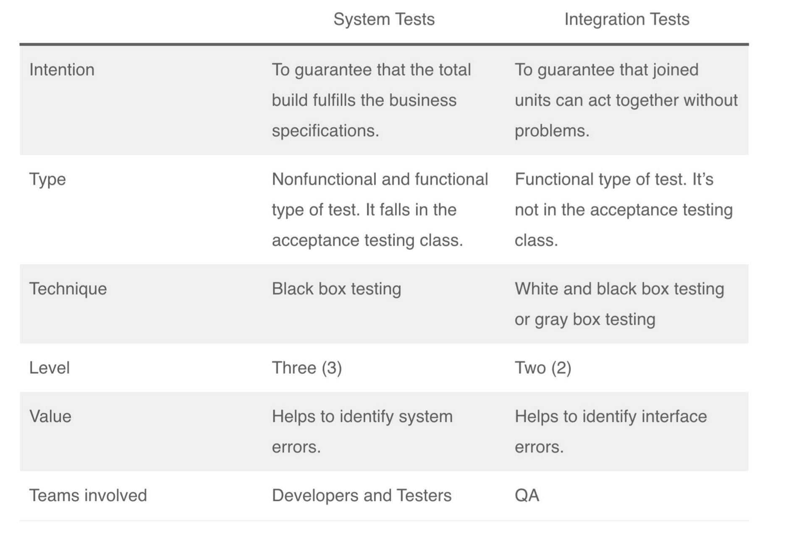

**System Testing vs Integration Testing**

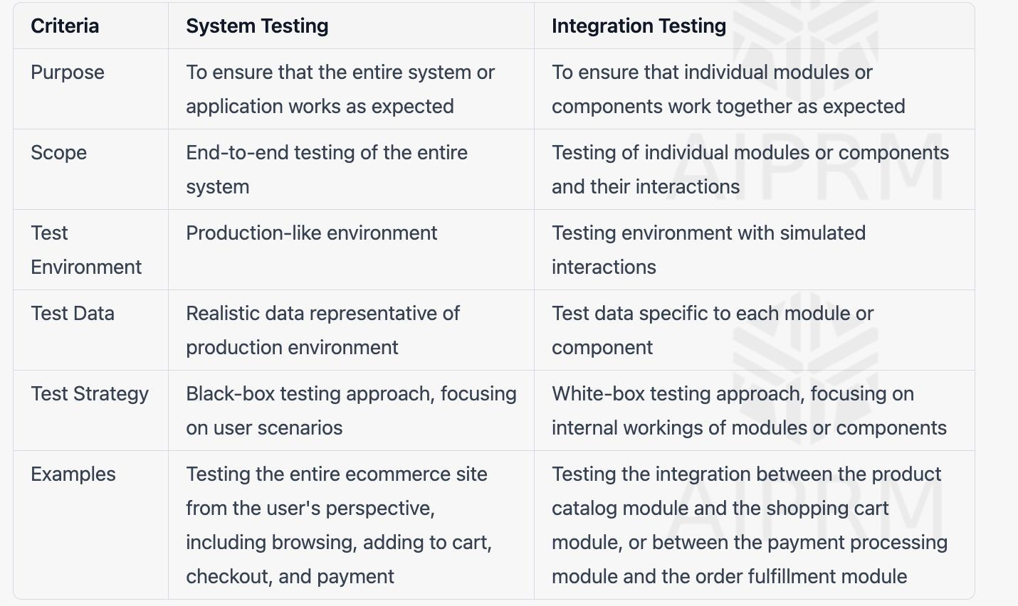

**System Testing vs E2E Testing**

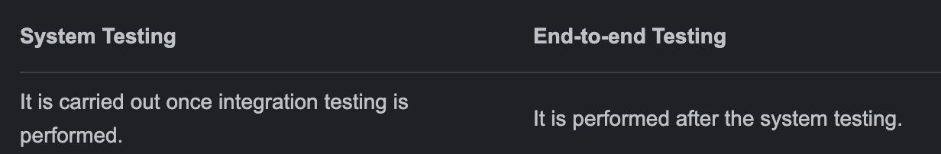

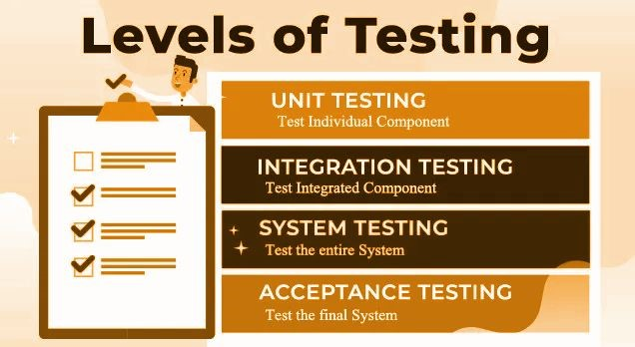

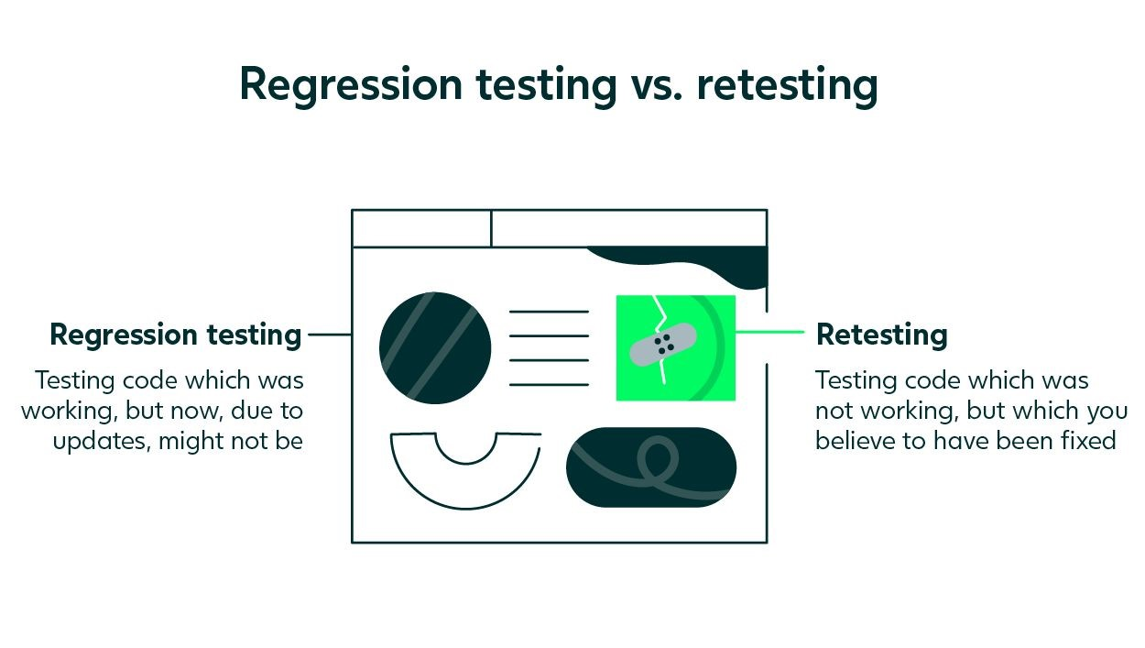

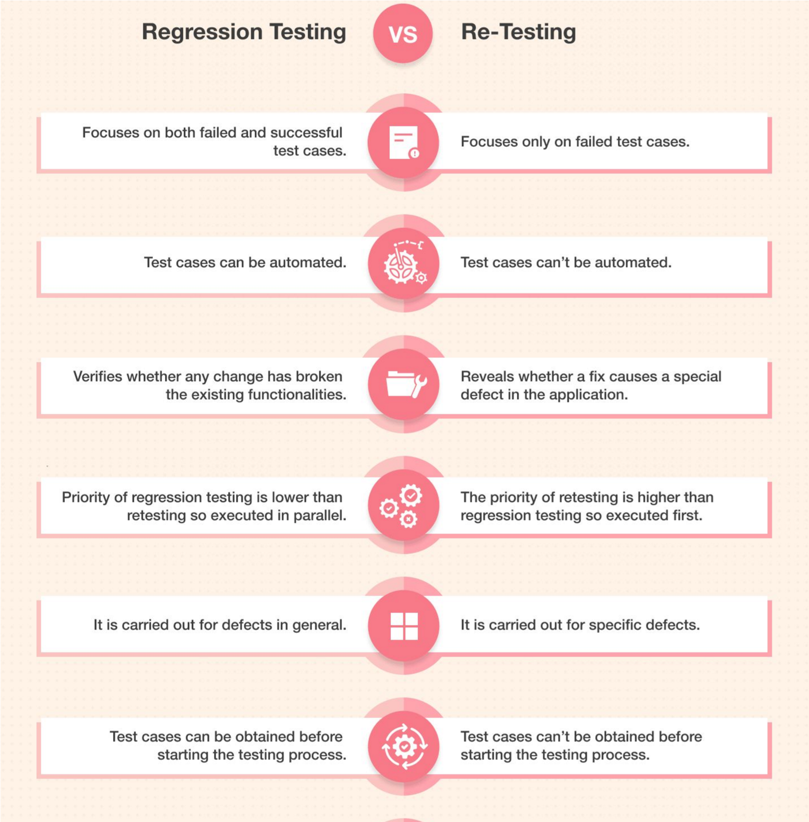

Manual Tester / Software Tester Roles and Responsibilities Manual Tester / Software Tester Roles and Responsibilities

* **Gather requirements from team**
* Prepare Test Plan, Test Scenarios, Test cases - https://sdet.live/3DbA
* Verifying the Software Web/ App by Hand
* Execute the Test cases and Report Bugs
* Send Test report to stakeholders
* More concentrated on the UI/UX issues
* In charge of paperwork(aka documentation online)

##### Manual Tester Roles and Responsibilities

Test environment setup

Participation in meetings

Analysis of customer requests

Software bug tracking

Analysis and execution of test cases

Maintaining contact with test managers

#### What you do can extra? As Manual tester

* Help in preparing the requirements to PM
* Share a Video or Images of the Manual flows to automation team, so that they can create better automation.
* Help the team pm, devs to sync and come with timelines of release.
* Learn coding and help in automation of the flows manual tested.
* Identify the automation flows and pain manual areas automate them using scripts

#### What you do can extra? As Manual tester

https://forms.gle/KcCe2bhZSFsS5GzLA

##### Software Development Life Cycle

Software Development Life Cycle (SDLC) is a process used by the software industry to design, develop and test high quality softwares.

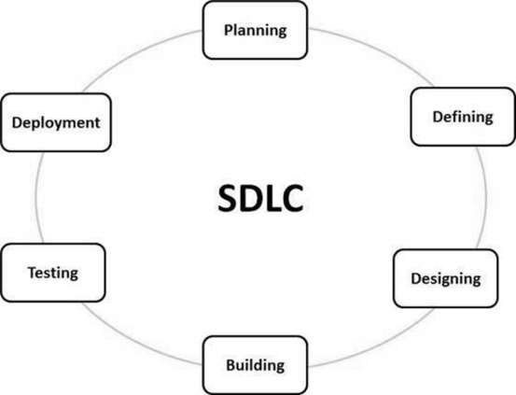ISO/IEC 12207 is an international standard for software life-cycle processes. It aims to be the standard that defines all the tasks required for developing and maintaining software.

1. Planning and Requirement Analysis

* It is performed by the senior members of the team with inputs from the customer.
* Sales department, market surveys and domain experts in the industry.

Documents - Statement of Work, Project Plan

Outcome - Various Technical approaches that can be followed to implement the project successfully with minimum risks.

https://bugz.atlassian.net/l/cp/EeXpfJ0W

SOW-TEMPLATE-Project Manager-ND

https://docs.google.com/document/d/1oP7Fw3RTvCdYuc1sH_1MeRYzOUhmtapr/edit?usp= sharing&ouid=104755920778477387077&rtpof=true&sd=true

###### 2. Defining Requirements

● Define and document the product requirements and get them approved from the customer or the market analysts

Documents - SRS (Software Requirement Specification) document https://sdet.live/samplesrs

Consists of all the product requirements to be designed and developed during the project life cycle.

https://www.geeksforgeeks.org/software-requirementspecification-srs-format/

###### 3. Designing

● Based on the requirements specified in SRS, usually more than one design approach for the product architecture is proposed and documented in a DDS - Design Document Specification

Documents - DDS

https://sdet.live/samplesrs

A design approach clearly defines all the architectural modules of the product along with its communication and data flow representation

###### 4. Building

 ● The programming code is generated as per DDS during this stage

Documents – FRDs

https://sdet.live/samplesrs

Developers must follow the coding guidelines defined by their organization and programming tools like compilers, interpreters, debuggers

###### 5. Testing

This stage refers to the testing only stage of the product where product defects are reported, tracked, fixed and retested, until the product reaches the quality standards defined in the SRS.

Documents - multiple Docs

https://sdet.live/notes

Full STLC Life Cycle

###### 6. Deployment

● Once the product is tested and ready to be deployed it is released formally in the appropriate market.

Documents - NA

The product may first be released in a limited segment and tested in the real business environment (UAT- User acceptance testing).

##### BRD

**Business Requirement Document i.e. BRD** is created during the initial phase of the project. This document contains the high-level business requirements that could be easy to follow by business stakeholders, managers, board of directors, etc.

a business requirement document is a functional business requirement that is written in a well-structured manner without any technical jargon.

|  |
| --- |
| Bank customers should be able to register themselves |

* Registered bank customers should be able to log in.
* Customers should be able to do online transactions.
* Customers should be able to open fixed deposit online.
* Customers should be able to recharge their mobile phones, etc.

##### FRD

**Functional specification document** is required with detailed requirements in technical terms that will be referred by the technical team for further development of the system.

* Username should not include numeric value.
* The password should be 8 or more char long.
* Only 5 transactions should be allowed in a day, etc

##### SRS

**Software Requirement Specification** i.e. SRS Document is one of the important documents for the development team. It is a **complete description of the behavior of a system to be developed.**

SRS document contains all the functional and non-functional requirements along with the use cases that the software must meet.

Software specification requirement document elaborates on the **business requirements mentioned in BRD** to accommodate the functional and non-functional requirements along with user intersections with the system i.e. use cases.

document is prepared by system analysts or business analysts and referred by the project management, development, and implementation teams.

UML **(Unified Modeling Language)** is a visual modeling language that is widely used in software engineering to represent **software designs.**

Standard language used for modeling software systems, and it includes various diagrams such as class diagrams, **use case diagrams, sequence diagrams, and state diagrams.**

Use case diagrams are a type of UML diagram that is often used in software testing

|  |  |
| --- | --- |
| Use case diagrams help testers understand the system's requirements and how it will | |
| be used by end-users. |  |

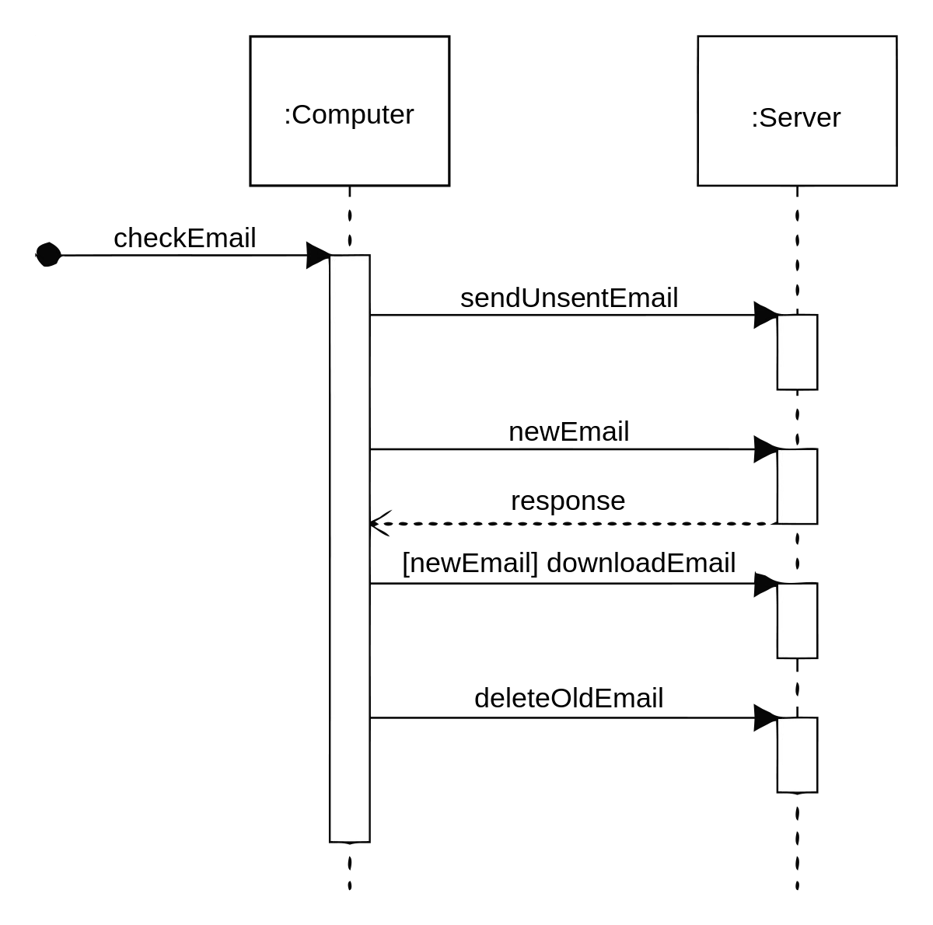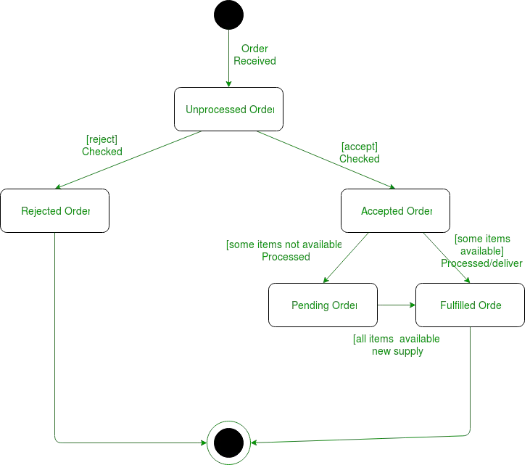

**sequence diagrams, and state diagrams.**

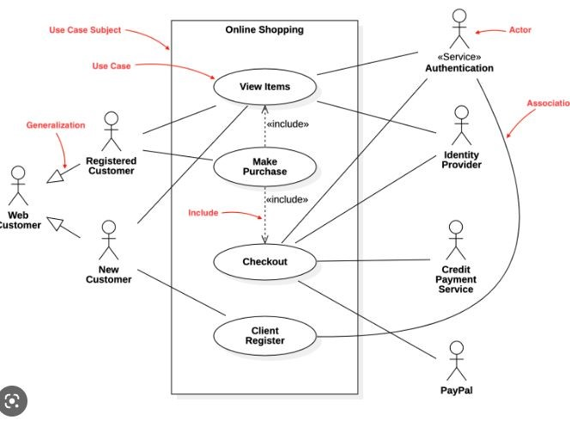

UML contains different diagrams and Use case is one of it

UML also contains Structural diagrams as well as - such as Class Diagram

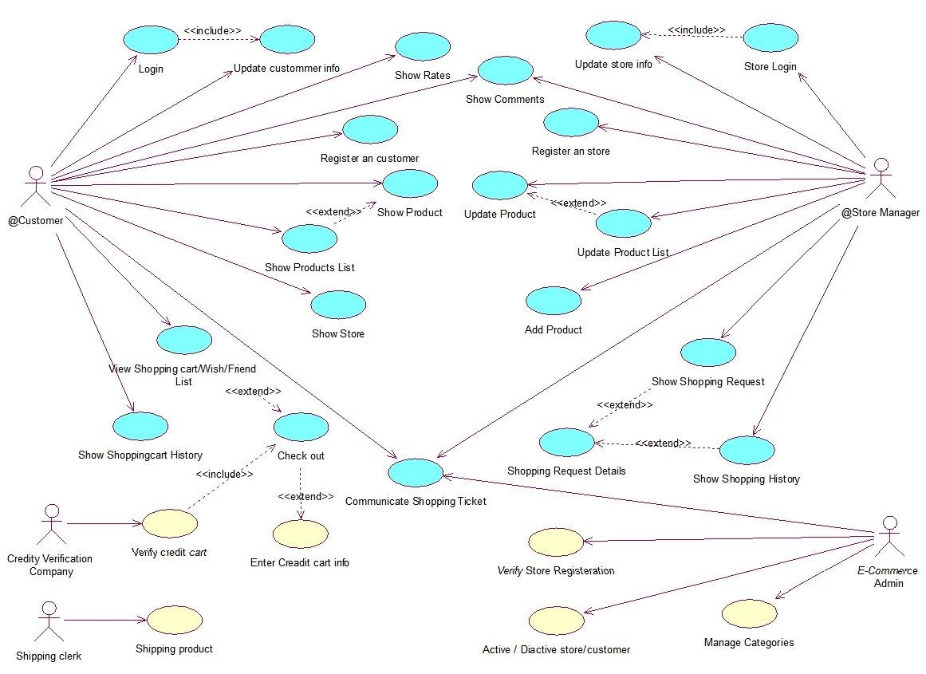

https://stackoverflow.com/questions/9107448/uml-class-diagram-for-an-e-commerce-website

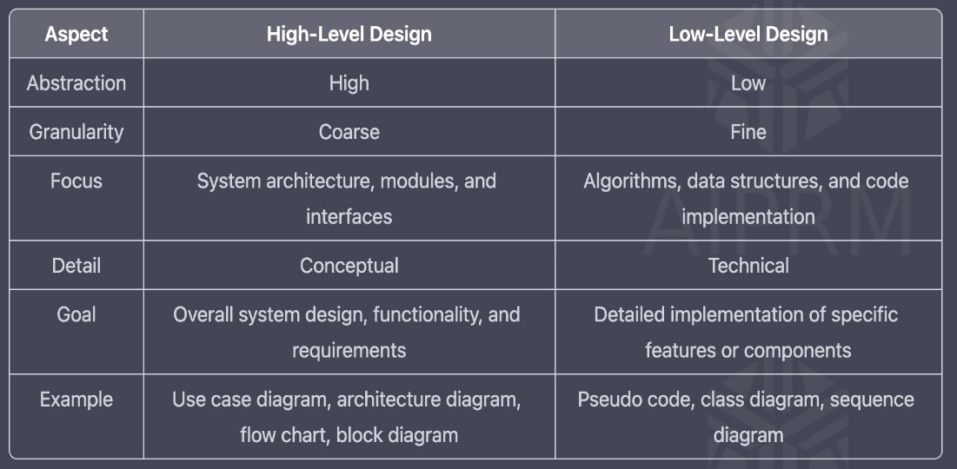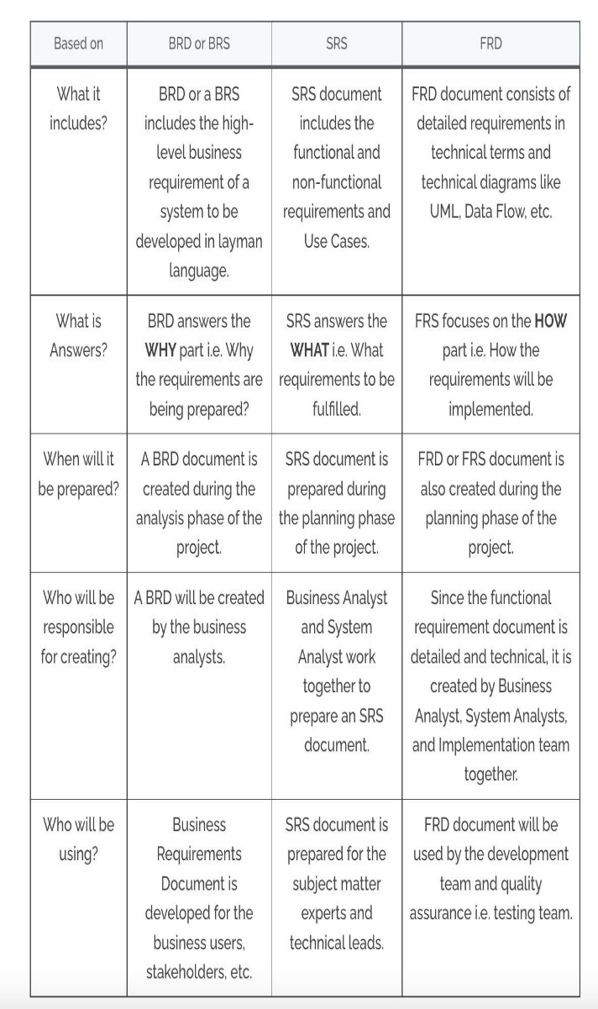

##### SDLC Models

* Waterfall Model
* Spiral Model
* V-Model
* Agile Model

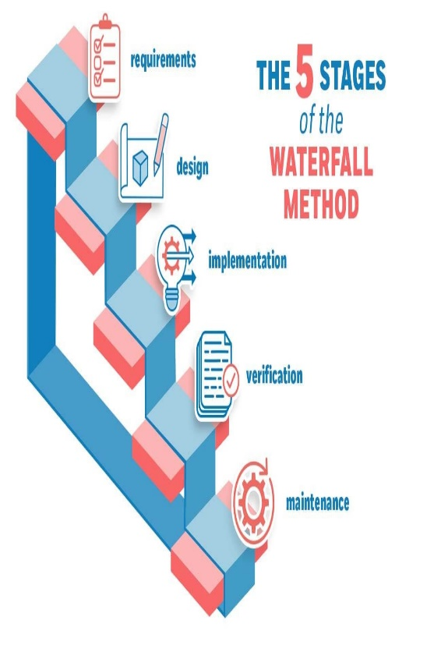Other related methodologies are Agile Model, RAD Model, Rapid Application Development and Prototyping Models.

##### Waterfall Model

##### Waterfall Model

**Advantages of Waterfall Model** ● The product will be of high quality.

* There are less possibilities of detecting problems because requirement modifications are prohibited.
* Since the testers are employed later, the initial cost is lower.
* Preferred for little projects with frozen criteria.

**Disadvantages of Waterfall Model •** Requirement changes are not allowed.

* + If there is defect in Requirement that will be continued in later phases.
  + Total investment is more because time taking for rework on defect is time consuming which leads to high investment.
  + Testing will start only after coding

#### Spiral Model

Spiral Model is iterative model. ▪ Spiral Model overcome drawbacks of Waterfall model.

▪ We follow spiral model whenever there is dependency on the modules.

▪ In every cycle new software will be released to customer.

▪ Software will be released in multiple versions. So it is also called version control model.

The Radius of the spiral at any point represents the expenses(cost) of the

project so far, and the angular dimension represents the progress made so far in the current phase.

**Prototyping Model**

Prototyping is defined as the process of developing a working replication of a product or system that has to be engineered. It offers a small scale facsimile of the end product and is used for obtaining customer feedback as described below:

In each phase of the Spiral Model, the features of the product dated and analyzed, and the risks at that point in time are identified and are resolved through prototyping. Thus, this model is much more flexible compared to other SDLC models.

**Risk Handling in Spiral Model**

A risk is any adverse situation that might affect the successful completion of a software project. The most important feature of the

spiral model is handling these unknown risks after the project has

started. Such risk resolutions are easier done by developing a prototype. The spiral model supports coping up with risks by providing the scope to build a prototype at every phase of the software development.

**Advantages of Spiral Model**

* Testing is done in every cycle, before going to the next cycle.
* Customer will get to use the software for every module.
* Requirement changes are allowed after every cycle before going to the next cycle**.**

**Disadvantages of Spiral Model**

* Requirement changes are NOT allowed in between the cycle.
* Every cycle of spiral model looks like waterfall model.
* There is no testing in requirement & design phase.

##### V-Model

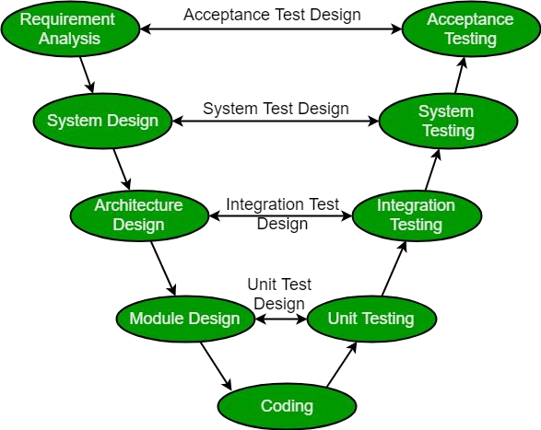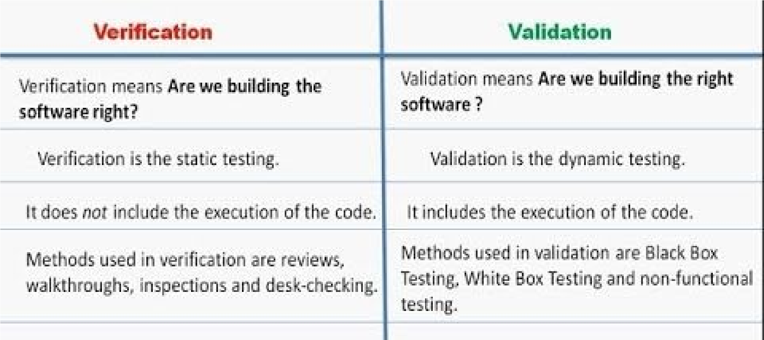The V-model is a type of SDLC model where process executes in a sequential manner in V-shape.

V-Model contains Verification phases on one side of the Validation phases on the other side.

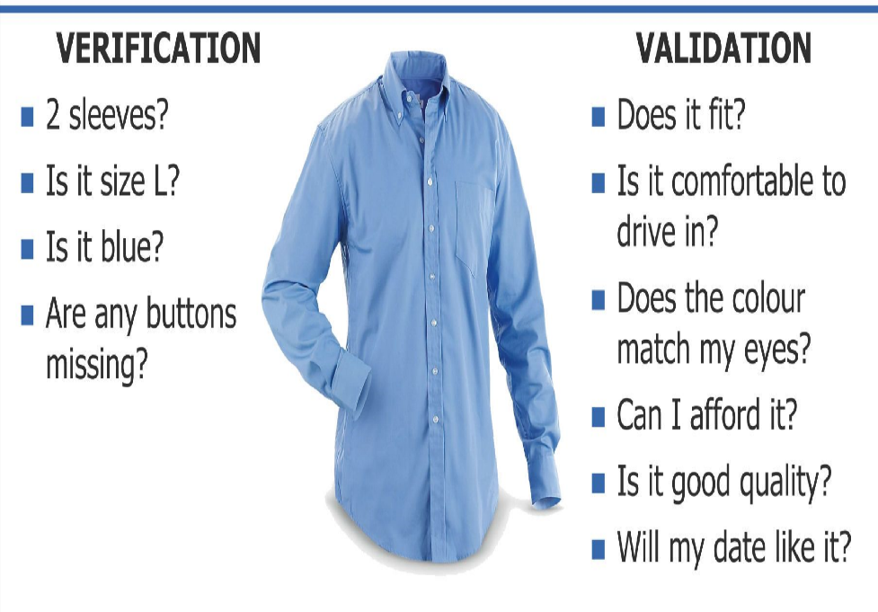

**Verification**: It involves static analysis technique (review) done without executing code. It is the process of evaluation of the product development phase to find whether specified requirements meet.

**Validation**: It involves dynamic analysis technique (functional, non-functional), testing done by executing code. Validation is the process to evaluate the software after the completion of the development phase to determine whether software meets the customer expectations and requirements.

**Advantages**

* Testing is involved in each and every phase.

**Disadvantages**

* 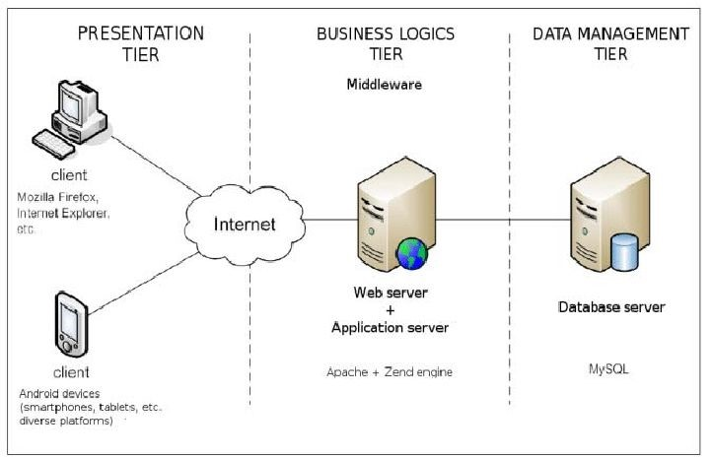Documentation is more.
* Initial investment is more.

**Static V/S Dynamic Testing**

Static testing is an approach **to test project documents in the form of Reviews, Walkthroughs and Inspections.**

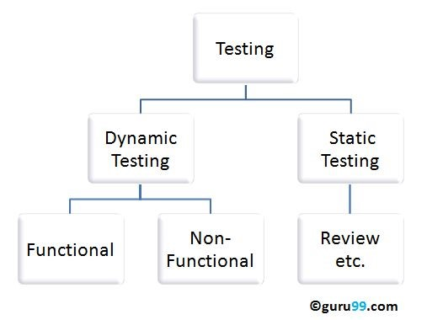Dynamic testing is an approach **to test the actual software by giving inputs and observing results.**

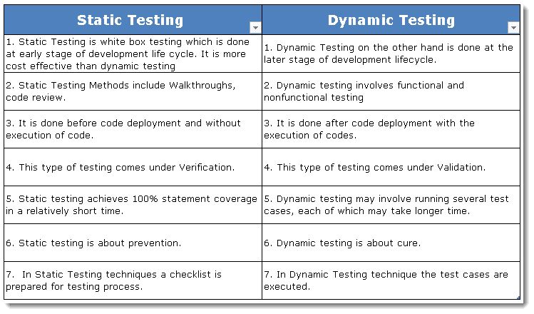

#### AGILE MODEL

The Agile model is a combination of an incremental and iterative approach and is focussed on fitting in well with **flexible requirements.**

Agile is an iterative approach to project management and software development that helps teams deliver value to their customers faster and with fewer headaches

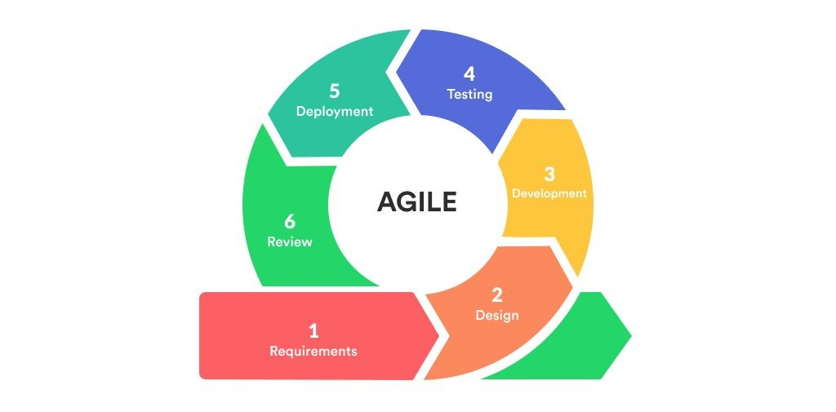the project is divided into small subparts and is delivered in iterations. The subtasks are divided into time frames to serve working functionality with each build. As a result, the final product has all the required features.

Instead of betting everything on a "big bang" launch, an agile team delivers work in small, but consumable, increments.

**Benefits:**

Quick development

Quality and measurable results Business value can be delivered – demonstrated fast Requires minimum resources

Highly adaptive to changing requirements

Better Resume Tech.

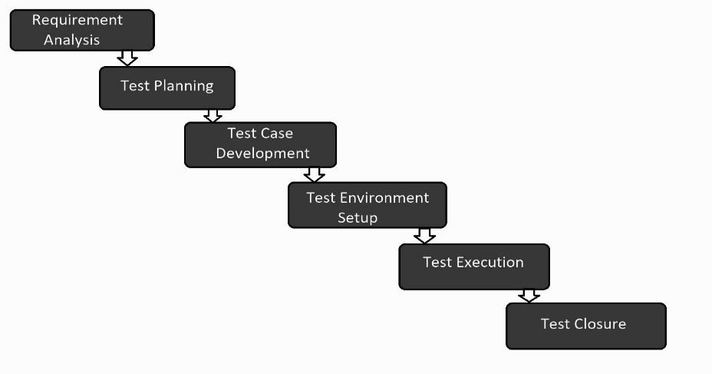**Software Testing Life Cycle (STLC)**

**Software Testing Life Cycle (STLC)** is a sequence of different activities performed during the software testing process.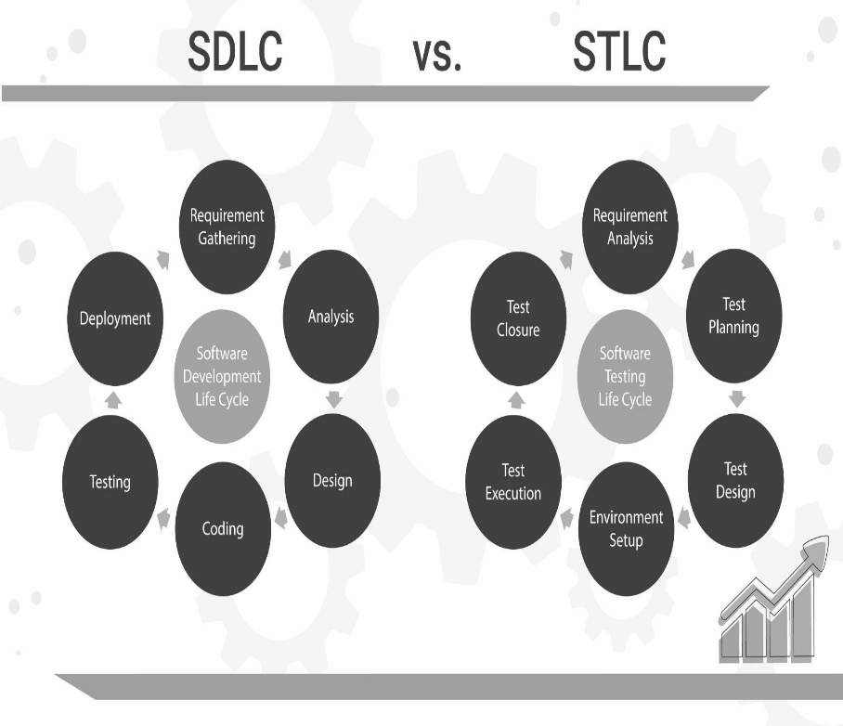

1. **Requirement Analysis:** Quality assurance team understands the requirements like what is to be tested. If anything is missing or not understandable then quality assurance team meets with the stakeholders to better understand the detail knowledge of requirement. - **Documents - SRS, FRD, BRD**
2. **Test Planning:** In this phase manager of the testing team calculates estimated effort and cost for the testing work. This phase gets started once the requirement gathering phase is completed. Documents **Test Plan**

**Test Case Development:** The test case development phase gets started once the test planning phase is completed Test cases. **Documents - Test cases(Excel, GSheet or on Tools)**

**Test Environment Setup:** Test environment decides the conditions on which software is tested. NA

**Test Execution: Documents - Test Execution Report Bug Report ,**

In this phase testing team start executing test cases based on prepared test cases in the earlier step.

**Test Closure: Test Report**

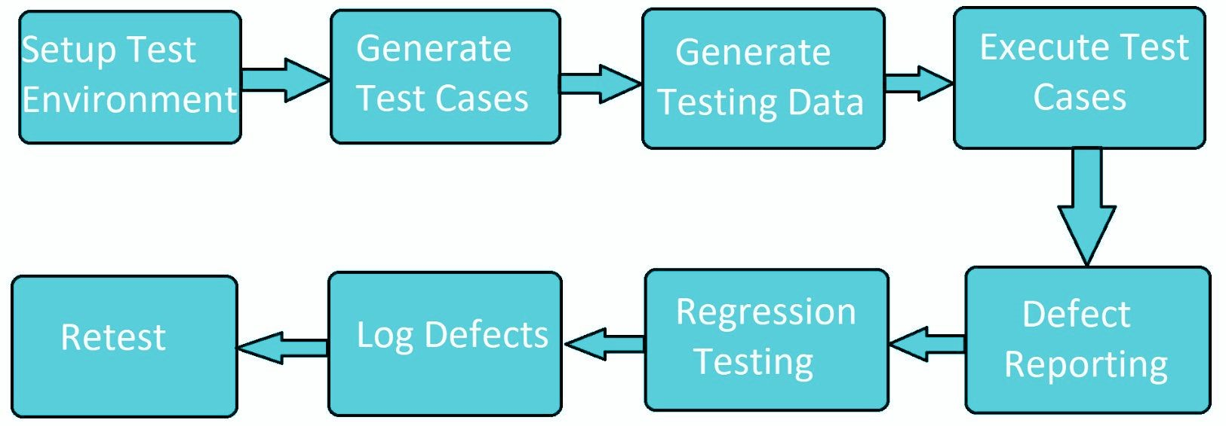This is the last stage of STLC in which the process of testing is analyzed.

##### Static Testing

**Static Testing** is a type of a Software Testing method which is performed to check the defects in software without actually executing the code of the software application.

**Static Testing done with Static Analysis**

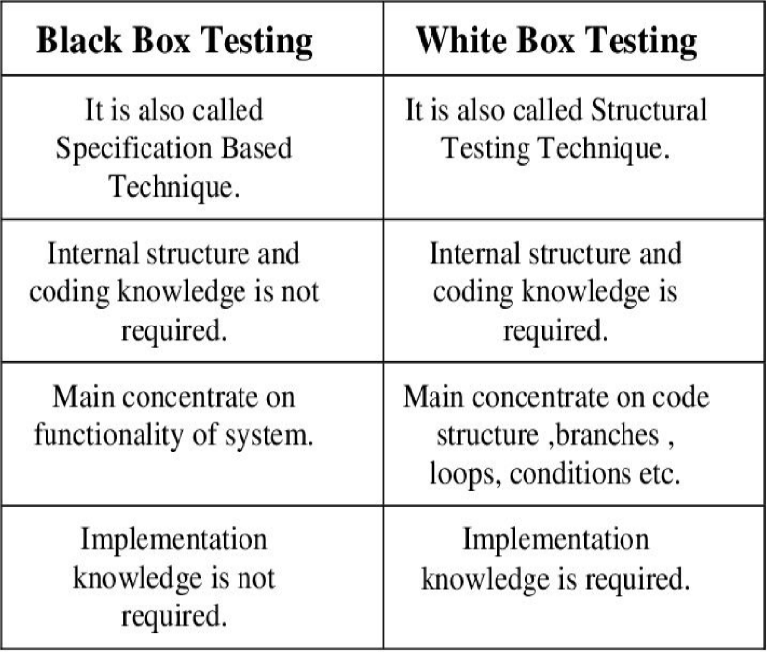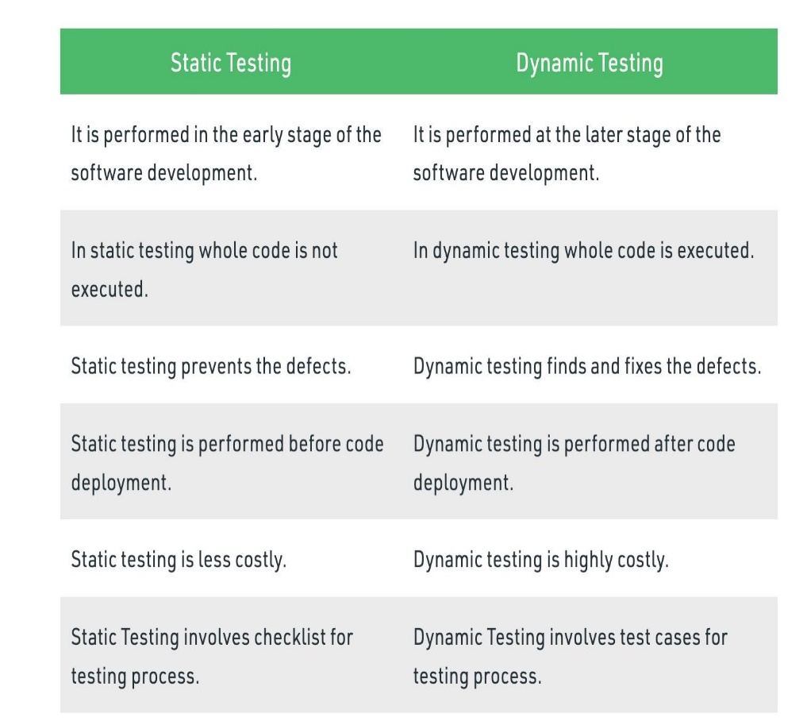 Static Analysis:

Static Analysis includes the evaluation of the code quality that is written by developers. Different tools are used to do the analysis of the code and comparison of the same with the standard.

It also helps in following identification of following defects:

1. Unused variables
2. Dead code
3. Infinite loops
4. Variable with undefined value
5. 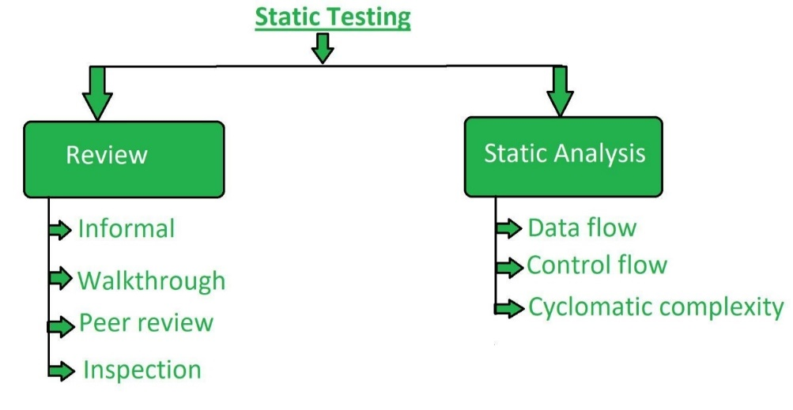Wrong syntax

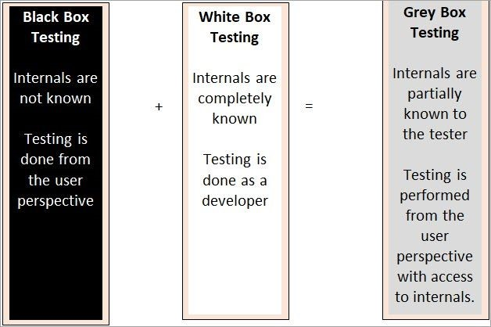**Testing Methodologies**

White box Testing

Black box Testing

Grey box Testin

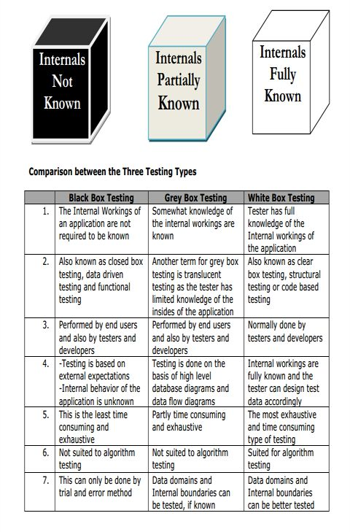

**Unit Testing**Unit Testing

**A unit is a single component**

or module of a software.

Unit testing conducts on a single program or single module.

Unit Testing is white box testing technique.

**Conducted by the developers.**

Unit testing techniques:

-

Basis path testing

-

Control structure testing

-

Conditional coverage

-

Loops Coverage.

-

Mutation Testing

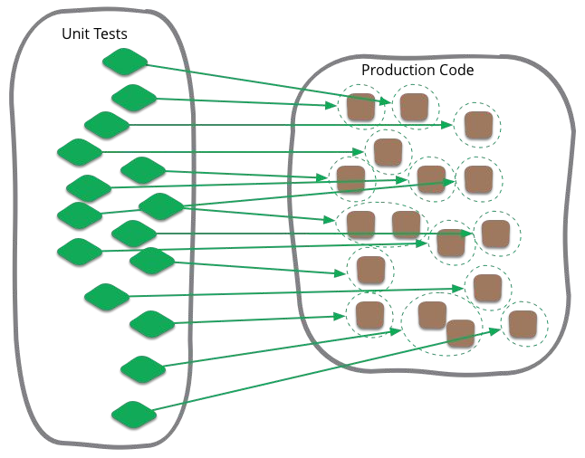

Demo of Web App unit

isSumPositive function



**Integration Testing**

●

-

Integration testing performed between 2 or more modules.

●

-

Integration testing focuses on checking

**data communication**

**between multiple**

●

modules.

●

-

Integrated Testing is white box testing technique

●

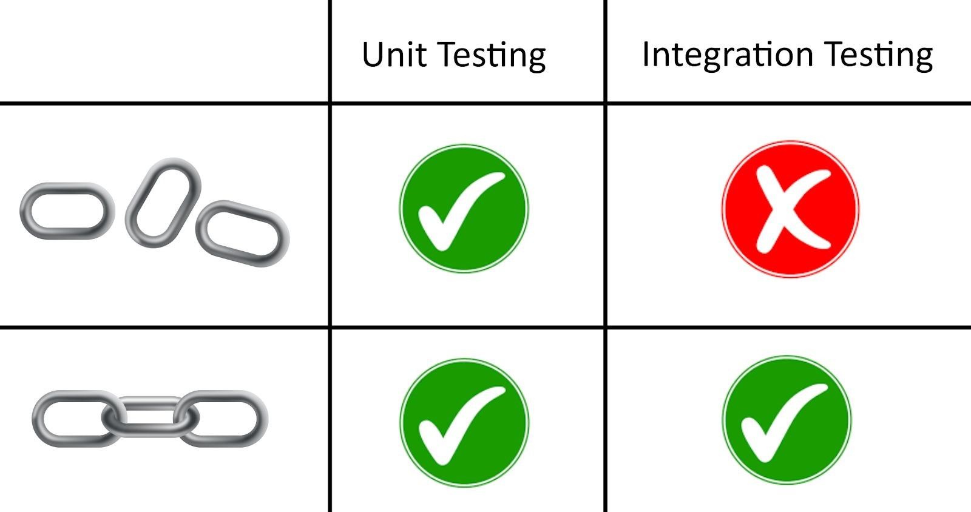

|  |  |
| --- | --- |
| ● Incremental |  |
| ● Big Bang Approach | |

**Big Bang Approach**

|  |  |
| --- | --- |
| All the components or modules are integrated | |
| together at once and then tested as a unit. |  |

Convenient for small systems.

**We might miss data flow between some of the modules.**

**If you find any defect we can’t understand the root cause of defect**

**some interfaces link to be tested could be missed easily.**

* Since the Integration testing can commence only after “all” the modules are designed, **the testing team will have less time for execution in the testing phase.**

high-risk critical modules are not isolated and tested on priority.